ZAMBIA: CONSTRUCTING NEW CHURCHES

THE NEED

The Evangelical Lutheran Church in Zambia is growing fast – so fast it needs more church buildings.

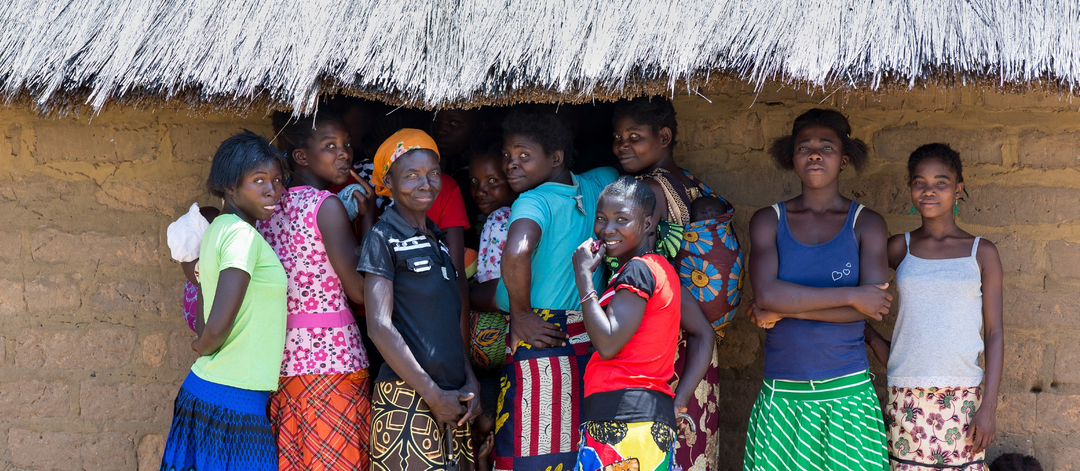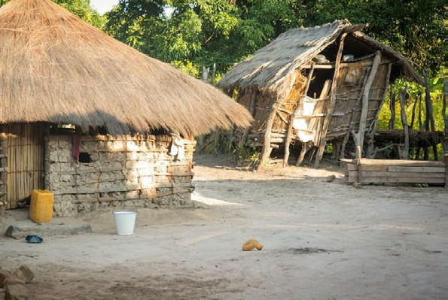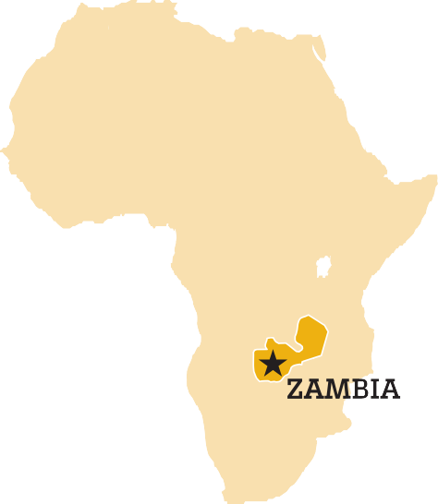This young, vibrant church now has nearly 6,000 members in 40 worshiping communities spread across four provinces. Of those 40 worshiping communities, only four have sturdy, weatherproof buildings. “The rest meet in thatched pole-and- mud structures. There are instances when members would find themselves worshiping under a tree because their building collapsed in a windstorm,” says the Rev. Alfred Chana, former senior pastor
of the Evangelical Lutheran Church in Zambia.
In order to grow as a church, our companion needs stronger buildings. Former ELCA missionary Arden Strasser describes it: “The fact is, sometimes in Africa, a church just needs bricks and mortar
to meet, especially during the rainy season.

“It’s not about the building; it’s what goes on inside the building. And we’ve seen,
when you have a brick-and-mortar church that can stand up the whole year round, you can get a lot happening in there.”
The Evangelical Lutheran Church in Zambia has proposed an exciting new initiative in partnership with the ELCA through its Global Ministries program. With the support of ELCA members and
congregations, together, we can raise

$500,000
to build up to 15 permanent
church buildings in Zambia, starting
with a leadership training center to support the pastors and evangelists who serve the growing church. With your help, we can make this possible and grow the church in Zambia.
Pastor Chana foresees that congregations with modern
buildings “will attract local community members, will not suspend worship in case of a rainy day or a windstorm, and can hold workshops and seminars.”
Pastor Strasser continues, “A church structure is the hatching place for ideas and motivation. It matters!”

ABOUT ELCA GLOBAL MINISTRIES

The ELCA has deep, long-standing relationships with more than 80 Lutheran churches around the world. As part of a global Lutheran community, we work alongside our brothers and sisters to spread the good news of Jesus Christ near and far.
Because we can do more together than we can as individual congregations, the ELCA listens to our companion church bodies around the world and responds to their requests for financial support to expand their ministries – to start new congregations, extend outreach in urban areas, and train pastors and evangelists. We call these joint evangelism projects Global Ministries.
The initiative in Zambia is one of 14 new Global Ministries introduced as part of Always Being Made New: The Campaign for the ELCA.

HELP U DO MORE!
S ONLINE | Make a secure credit card donation by visiting www.ELCA.org/campaign.
MAIL | Make checks payable to ELCA Global Church Sponsorship with “Zambia: Constructing New Churches—GCS4036” in the check’s memo line. Mail checks to: ELCA, P.O. Box 1809, Merrifield, VA 22116-8009.
OTHER WAYS  TO GIVE | For other ways to give, including multi-year pledges,  gifts of securities or real estate and planned gifts, please call  800-638-2612, ext. 2612, or email CampaignforELCA@elca.org.

Make a gift to Zambia: Constructing New Churches.

THE CAMPAIGN FOR THE ELCA
Always Being Made New: The Campaign for the ELCA is our moment to look toward the future of this church and boldly respond to the needs of the world with a living, daring confidence in God’s grace. This five-year, $198 million campaign will help our church grow our communities of faith, form new leaders, welcome our neighbors, overcome malaria, confront hunger and poverty, accompany our global churches and so much more. Together, we can achieve things on a scale and scope we could never do otherwise.

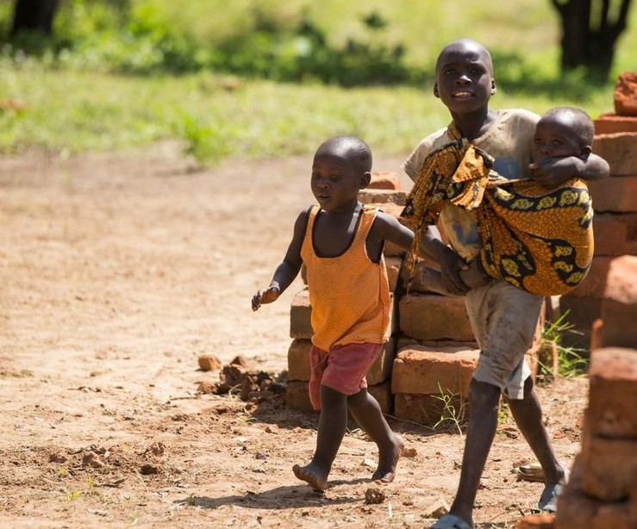

Evangelical Lutheran Church in America
8765 West Higgins Road • Chicago, IL 60631-4101 800-638-3522 • ELCA.org
© 2015 Evangelical Lutheran Church in America

